Week 2 Assignment Lane Dorscher
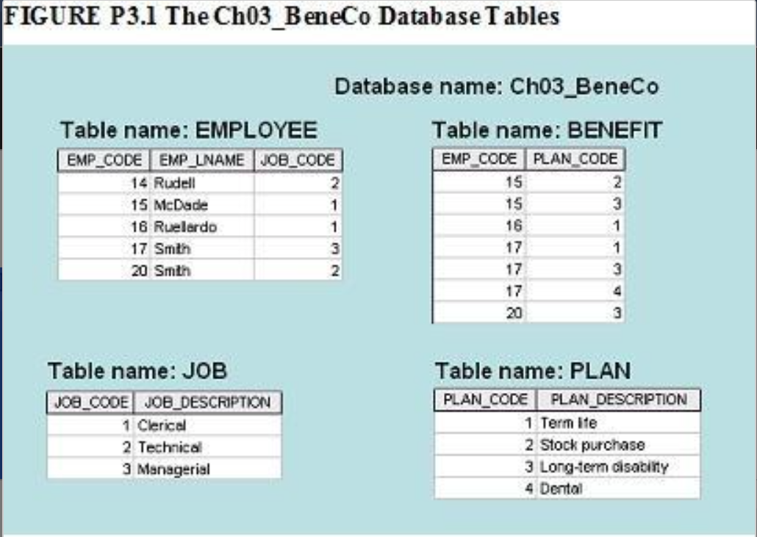
Problem 1: For each table in the database above, identify the primary key and the foreign key(s). If a table does not have a foreign key, write None in the assigned space provided. Use the following format to show your answers.
TABLE | PRIMARY KEY | FOREIGN KEY(S)
EMPLOYEE | EMP_CODE | JOB_CODE
BENEFIT | EMP_CODE, PLAN_CODE (composite key) | EMP_CODE, PLAN_CODE
JOB | JOB_CODE | None
PLAN | PLAN_CODE | None

Problem 2: Create Crow's foot to show the relationships among EMPLOYEE, BENEFIT, JOB, and PLAN.
